**Name: Kashan Humayun**

**Sap Id: 24773**

**Q1:** Display the report of all those employees whose income is less than those who work in department numbers 50, 20, and 10.

select * from employees

where salary<ANY(select salary from employees

where department_id in(50,20,10));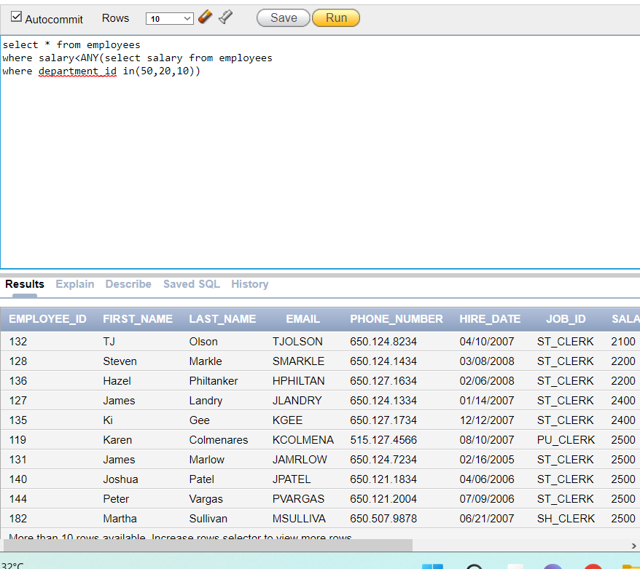

**Q2:** Write a query that displays the employee number and last name of all employees who work in a department with any employee whose last name contains ‘a’ and ‘u’.

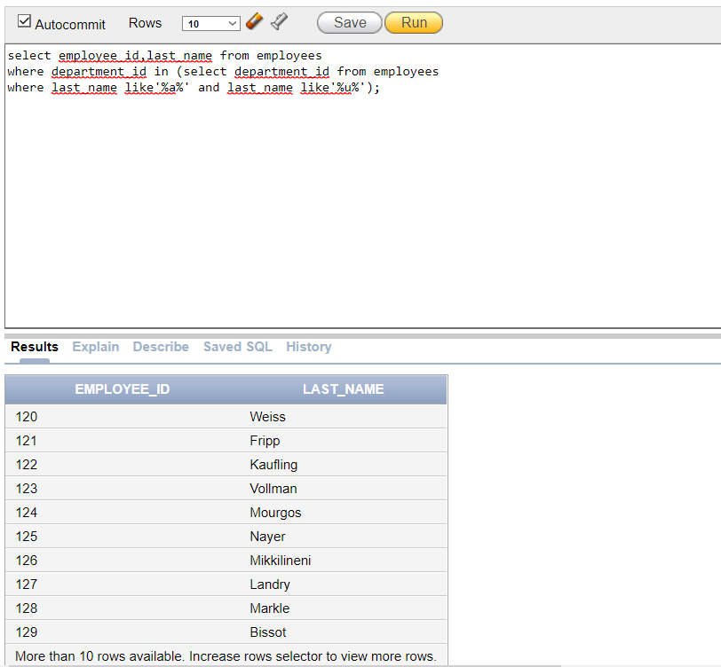

**Q3:** The HR department needs a report that displays the last name, department number, and job ID of all employees whose department location ID is 1700.

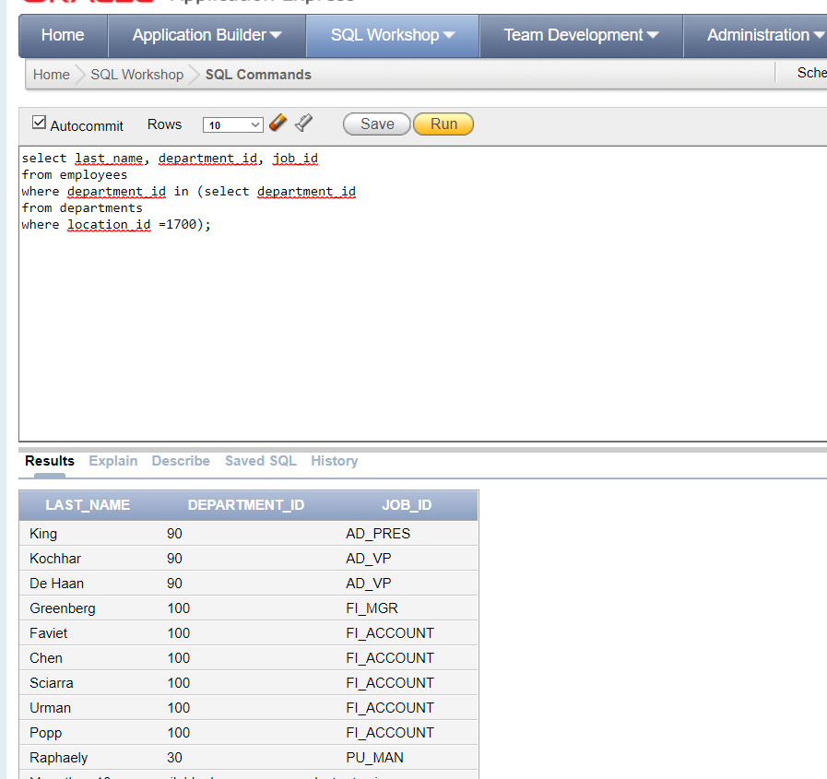

**Q4:** Display the job number and job title of those employees whose maximum salary is greater than 'ST_MAN'.

select job_id,job_title from jobs

where max_salary>(select max_salary

from jobs where job_id='ST_MAN');

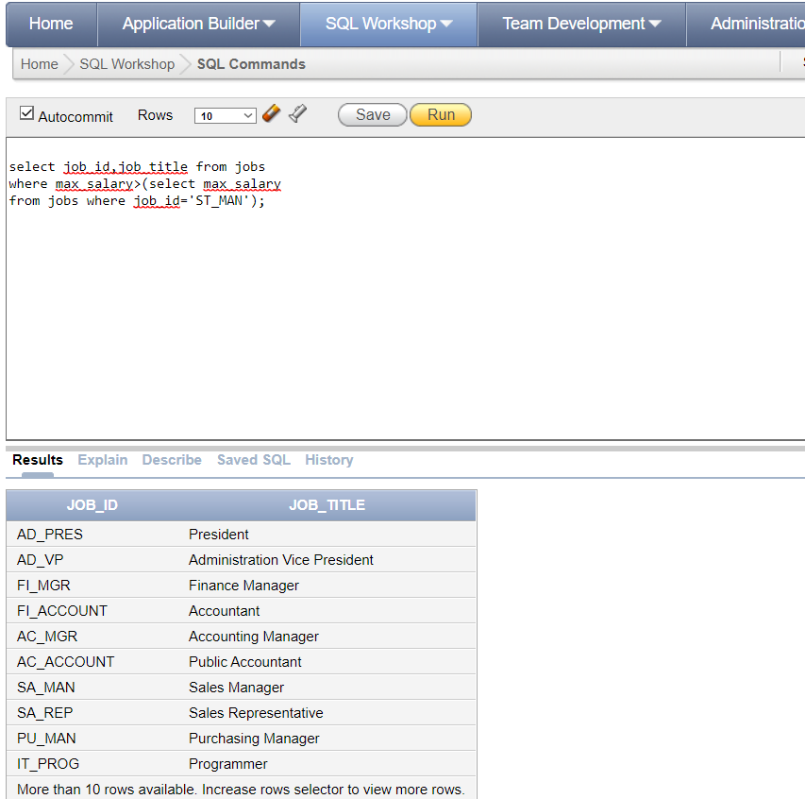

**Q5:** Show a report that displays the employee number, first name, and salary of all employees who earn more than the average salary. Sort the results according to salary in ascending order.

select employee_id, first_name, salary

from employees

where salary > (select avg(salary)

from employees)

order by salary;

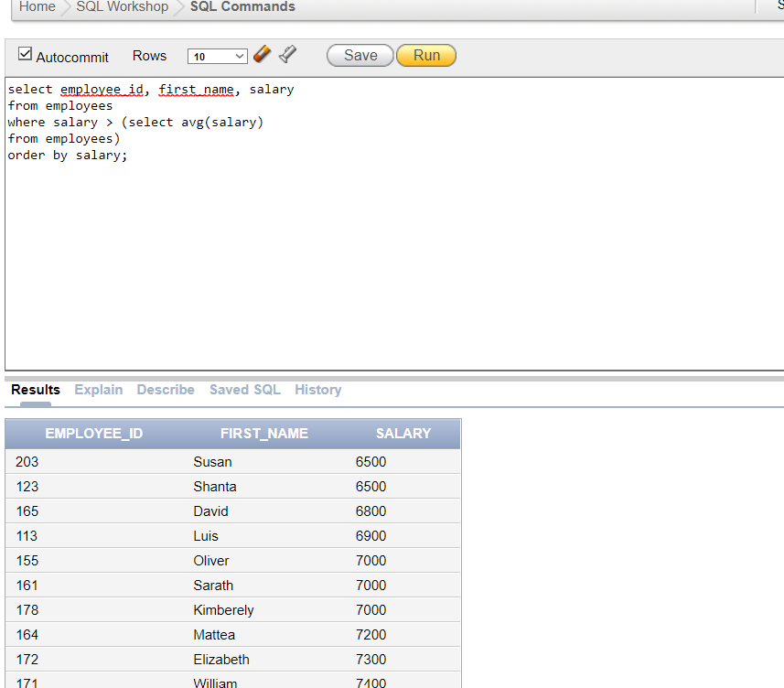

**Q6:** Display all the departments that have a minimum salary greater than that of department 50 ?

select department_id,MIN(salary)

from employees

group by department_id

having Min(Salary) > (select MIN(salary)

from employees

where department_id=50);

